

MSc Data Science Project
7PAM2002-0901-2025
Department of Physics, Astronomy and Mathematics

Data Science Final Project Report

Project Title :
Predicting Delivery Time Deviations in Logistics Using Machine Learning

Student Name and SRN:
Tarun Reddy Salevenkayalla and 23098031

Supervisor: Sugatha Kaviraj
Date Submitted: 05/01/2026
Word Count:4998

Declaration statement :
This report is submitted in partial fulfilment of the requirement for the degree of Master of Science in Data Science at the University of Hertfordshire.
I have read the detailed guidance to students on academic integrity, misconduct and plagiarism information at Assessment Offences and Academic Misconduct and understand the University process of dealing with suspected cases of academic misconduct and the possible penalties, which could include failing the project or course.
I certify that the work submitted is my own and that any material derived or quoted from published or unpublished work of other persons has been duly acknowledged.
I did not use human participants in my MSc Project.

I hereby give permission for the report to be made available on module websites provided the source is acknowledged.

Student Name printed: Tarun Reddy Salevenkayalla

Student Name signature : Tarun Reddy Salevenkayalla

Student SRN number: 23098031

UNIVERSITY OF HERTFORDSHIRE
SCHOOL OF PHYSICS, ENGINEERING AND COMPUTER SCIENCE

Acknowledgement:

I would like to express my sincere appreciation to my academic supervisor for their valuable guidance, constructive feedback, and continued support throughout the development of this project. Their expertise and direction were instrumental in shaping the academic quality, methodology, and clarity of this work.

I am also grateful to the academic staff of the MSc Data Science programme for providing a strong theoretical and practical foundation in machine learning, data analytics, and research methods, which significantly contributed to the successful completion of this project.
In addition, I acknowledge the use of generative artificial intelligence tools for language refinement, structural guidance, and proofreading support. All data processing, feature engineering, model development, experimentation, evaluation, interpretation of results, and code implementation were independently performed, validated, and finalised by the author.

Finally, I would like to thank my family and friends for their encouragement, patience, and support throughout my academic journey.

Contents
Declaration statement : 2
Acknowledgement: 3
GitHub: 8
Abstract: 9
Introduction: 10
1.1 Aim 10
1.2 Research Question 10
1.3 Objectives 10
2. Literature Review 11
3. Project Workflow Chart 12
3.1 Project Workflow Overview 12
4. Dataset Overview: 13
4.1 Ethical Implications 14
5.1 Research Design 16
5.2 Data Pre-processing 16
5.2.1. Data Cleaning 16
5.2.2. Temporal Feature Extraction 17
5.2.3. Normalisation of Numerical Features 17
5.2.4. Feature Engineering 17
5.2.5. Enhanced Target Creation 17
5.2.6. Train–Test Split 17
1. Exploratory Data Analysis (EDA) 18
6.1 Distribution of the Target Variable 18
6.2 Distribution of Key Predictor variables 18
6.3 Correlation Analysis 20
7.Feature Engineering 20
7.1 Target Variable Construction 21
7.4 Temporal Variables: 21
8. Model Description 21
8.1 Gradient Boosting Regressor 21
8.2 Hist Gradient Boosting Regressor 22
8.4 Extra Trees Regressor 24
9.Results and Evaluation 24
9.1 Model Performance and Comparison 25
Table 9.1 – Performance Metrics for All Models 25
9.2 Prediction Accuracy Analysis 25
9.2.1 Actual vs Predicted Delivery Time Deviation 25
9.2.2 Sample Prediction Comparison 26
9.3 Interpretation of Model Performance 27
10. Analysis and Discussion 28
10.1 Comparison with Existing Literature 28
13. Future Work 30

Project Title :
Predicting Delivery Time Deviations in Logistics Using Machine Learning

GitHub:

Abstract:

Predicting delivery time deviations remains a persistent challenge in modern logistics due to numerous variables such as operational inefficiencies, environmental disruptions, and human factors. This study explores the use of machine learning models to forecast such deviations by leveraging a rich dataset encompassing traffic conditions, weather events, port congestion, customs processing durations, route-specific risks, and driver behaviour indicators. The dataset was specifically enhanced to mirror the complex, real-world interactions typical of supply chain operations.
Four supervised learning algorithms, Gradient Boosting, Hist Gradient Boosting, Random Forest, and Extra Trees, were trained and assessed. Among these, Gradient Boosting achieved the highest accuracy with an R² score nearing 0.97, underscoring its capability to model non-linear relationships effectively. Analysis of feature importance revealed customs clearance time, port congestion, and traffic intensity as key contributors to delivery time variance.
The outcomes affirm that machine learning, when applied to multifactorial and high-quality datasets, provides a powerful method for anticipating delays in logistics. This project contributes to the growing field of intelligent logistics by demonstrating the predictive benefits of comprehensive datasets in operational decision-making

Introduction:

Timely delivery is a fundamental requirement for effective supply chain management, particularly as global commerce expands, and transportation systems grow more complex. However, logistical operations often encounter disruptions from factors such as traffic congestion, adverse weather, port delays, and variations in driver performance. These uncertainties can significantly impair delivery reliability, elevate costs, and affect overall supply chain efficiency.
Conventional methods for managing delivery schedules often rely on retrospective analyses or static planning, which are limited in their responsiveness to real-time operational fluctuations. The growing adoption of technologies such as IoT sensors, telematics, and real-time tracking has opened new avenues for predictive modelling in logistics. In this context, machine learning offers a promising approach to modelling the intricate, interdependent factors that drive delivery performance.
Despite advancements in logistics analytics, many existing studies simplify the problem by focusing on isolated variables, thereby failing to capture the full spectrum of influences on delivery deviations. This research aims to bridge that gap by using a feature-rich dataset that reflects the complexity of modern logistics, incorporating operational, behavioural, environmental, and risk-based inputs. The goal is to evaluate the effectiveness of ensemble machine learning models in forecasting delivery time variations with greater accuracy and practical relevance.

1.1 Aim

This research aims to develop and evaluate machine learning models capable of accurately predicting delivery time deviation in logistics operations using a comprehensive dataset enriched with operational, environmental, behavioural, and risk-related factors.

1.2 Research Question

How accurately can machine learning models predict delivery time deviations in logistics operations using real-time operational, environmental, behavioural, and risk-related factors?

1.3 Objectives

- To construct an enhanced logistics dataset that captures realistic patterns and interaction effects influencing delivery time deviation.
- To conduct exploratory data analysis (EDA) to identify key operational, environmental, and behavioural factors affecting delivery schedules.
- To develop, train, and evaluate a set of supervised machine-learning models, namely Gradient Boosting, Hist Gradient Boosting, Random Forest, and Extra Trees for predicting delivery time deviation.
- To compare model performance using standard regression evaluation metrics, including Mean Absolute Error (MAE), Root Mean Squared Error (RMSE), and the coefficient of determination (R²), to identify the most accurate and robust predictive model.
- To analyse feature importance and determine the most influential variables contributing to delivery time deviation.
- To generate actionable insights that support proactive, data-driven decision-making in logistics planning and operational management.

2. Literature Review

The challenge of predicting delivery delays is central to contemporary logistics research, driven by the increasing demand for reliability in global supply chains. Numerous studies have investigated the impact of factors such as traffic congestion, adverse weather, and infrastructure bottlenecks on delivery timelines, with machine learning (ML) emerging as a dominant approach for modelling such multifaceted systems.

Recent research by Tavana et al. (2023) demonstrated that ensemble-based algorithms—particularly Random Forest and Gradient Boosting—outperform traditional linear models due to their ability to capture complex, non-linear relationships in transportation data. Similarly, Chen and Lee (2024) enhanced estimated time of arrival (ETA) predictions by integrating sensor data with environmental metrics, highlighting the importance of real-time signals in predictive modelling.

Operational delays such as customs processing and port congestion remain consistent sources of deviation. Prasad and Reddy (2021) emphasised the role of inspection protocols and cross-border regulations as critical influencers of delivery time, reinforcing the need for regulatory variables in predictive systems. Additionally, Lange et al. (2022) leveraged real-time telematics to improve model responsiveness to fluctuating logistics conditions, with boosting algorithms showing particularly strong adaptability.

The influence of weather is also well-documented. Huang et al. (2022) reported that severe weather, including rainfall and storms, significantly disrupts transportation schedules, making meteorological data an essential component in delay forecasting models.

While these studies provide valuable insights, many are limited by narrow feature sets—often focusing on a single domain such as traffic or weather. Moreover, some omit interaction effects between variables (e.g., how port congestion may amplify customs delays), which are critical for capturing real-world dynamics. This research addresses these limitations by introducing an enriched dataset combining operational, behavioural, environmental, and risk-related variables, along with engineered interaction terms to reflect compounded influences on delivery outcomes.

3. Project Workflow Chart








3.1 Project Workflow Overview

- Data Ingestion
Load the enhanced logistics dataset containing operational, environmental, behavioural, and risk-related variables.

- Data Cleaning
Validate data types, remove inconsistencies, and confirm completeness by ensuring there are no missing values across all variables.

3. Temporal Feature Extraction
Convert the timestamp into derived time-based features (hour, day of week, and month) to capture temporal delivery patterns.
4. Data Pre-processing
Normalise numerical variables to ensure consistent feature scaling, apply one-hot encoding to categorical variables, and standardise fields to support robust model training.

5. Feature Engineering
- Construct interaction terms (e.g., traffic × weather, port congestion × customs clearance time).
- Generate derived indicators (e.g., driver-risk measures, fatigue-related risk, and inventory pressure).
- Create an enhanced and realistic target variable representing delivery time deviation.

- Exploratory Data Analysis (EDA)
Analyse feature distributions and relationships, examine correlations with delivery time deviation, and identify key drivers of delay to confirm the presence of meaningful predictive patterns.

- Train–Test Split
Partition the dataset into 80% training and 20% testing subsets to ensure unbiased evaluation and generalisation assessment.

- Model Development
Train four ensemble-based regression models: Gradient Boosting, Hist Gradient Boosting, Random Forest, and Extra Trees.

- Model Evaluation
Evaluate predictive performance using MAE, RMSE, and R², and compare model behaviour and stability on the test set.

- Model Selection
Identify the most suitable model based on performance and generalisation, selecting Gradient Boosting as the best-performing approach.

- Results Interpretation
Interpret model outputs using residual analysis and feature importance to understand the primary drivers of delivery time deviation and explain differences in model performance.

Dataset Overview:

Data Set : https://www.kaggle.com/dataset-logistics and supply chain.

This study utilises a publicly available logistics and supply chain dataset obtained from Kaggle, published for research and educational purposes. The dataset contains over 32,000 delivery records and 26 attributes and was compiled to simulate real-world logistics operations across complex supply chain environments. According to the dataset documentation, the data represents aggregated delivery information generated to reflect realistic operational, environmental, and behavioural conditions commonly observed in global logistics networks.
Each record corresponds to an individual delivery event and includes temporal and spatial variables such as timestamps and GPS-based location data. Operational attributes include loading and unloading durations, fuel consumption, historical demand indicators, and lead time metrics. Categorical variables describe order fulfilment status and cargo condition, allowing both efficiency and service-quality analysis.
External disruption factors are also incorporated, including port congestion levels, weather severity indicators, and customs clearance durations, which reflect common causes of delivery delays in international logistics. Human-related variables such as driver behaviour scores and fatigue metrics are included to capture behavioural influences on delivery performance. In addition, sensor-derived attributes, including cargo temperature measurements, provide further insight into shipment handling conditions.
Exploratory Data Analysis (EDA) was conducted to examine feature distributions, identify correlations, assess missing values, and detect potential outliers. This analysis informed subsequent data pre-processing and feature engineering steps to ensure data quality and model suitability.
To support the project’s research objective of modelling delivery time deviations, a synthetic target variable representing delivery time deviation was constructed. This variable was generated using a weighted combination of relevant operational, environmental, and behavioural features, with Gaussian noise added to simulate real-world uncertainty. Interaction features, such as traffic_weather and port customs combinations, were also engineered to capture compound delay effects. This enhanced dataset provides a robust foundation for training and evaluating machine learning models aimed at understanding and predicting delivery delays.
From an ethical perspective, the dataset does not contain personally identifiable information and consists of anonymised, simulated operational records. No human participants were involved, and no primary data collection was conducted. As a result, formal University of Hertfordshire ethical approval was not required for this study, and the dataset complies with GDPR and institutional ethical guidelines.

4.1 Ethical Implications

The application of machine learning in logistics forecasting introduces several ethical considerations that must be carefully addressed to ensure the responsible, transparent, and fair use of predictive technologies. The dataset used in this study includes operational and behavioural indicators related to drivers and logistics personnel, such as fatigue monitoring scores and behaviour ratings. To protect individual privacy, all personally identifiable information was removed, and the dataset consists solely of anonymised and aggregated records. No direct identifiers are present, and individual subjects cannot be re-identified, thereby minimising privacy risks and supporting ethical data usage.
A further ethical concern relates to algorithmic bias. Machine learning models may inadvertently reinforce patterns present within historical data, potentially disadvantaging specific drivers, routes, regions, or operational practices. To mitigate this risk, model behaviour should be evaluated critically, and outputs should be monitored to identify potential bias. Ensuring fairness in predictions is particularly important when results are used to support operational planning and performance assessment.
The use of predictive models can also influence managerial decision-making within logistics organisations. Inaccurate or misinterpreted predictions may place undue operational pressure on personnel or result in unfair attribution of responsibility for delivery delays arising from external factors. For this reason, the models developed in this study are intended to function as decision-support tools rather than automated decision-making systems, with appropriate human oversight maintained.
Transparency and explainability are also essential ethical requirements. Stakeholders should be able to understand how predictions are generated, the assumptions underlying the models, and the limitations of the analytical approach. The inclusion of explainable techniques, such as feature importance analysis, supports accountability and trust in the modelling process.
From an institutional ethics perspective, this project did not require formal University of Hertfordshire ethical approval. The dataset was sourced from a publicly available repository, contains no personal data, and does not involve direct interaction with human participants, surveys, or experiments. All stages of data handling and model development comply with relevant data governance frameworks, including the General Data Protection Regulation (GDPR). Addressing these ethical considerations is essential for ensuring responsible innovation and trustworthy deployment of data-driven logistics systems.

5. Methodology
This section outlines the methodological framework used to develop machine learning models capable of predicting delivery time deviations in logistics operations. The study adopts a supervised learning approach, with a continuous target variable representing the difference between scheduled and actual delivery times, which is appropriate for regression-based predictive modelling (Hastie, Tibshirani and Friedman, 2009). The dataset includes a broad range of operational, behavioural, environmental, and risk-based features, allowing for a comprehensive analysis of factors influencing delivery performance.
The methodology follows a structured process to ensure analytical consistency and reproducibility. Key stages include dataset preparation, exploratory data analysis (EDA), feature engineering, model development, and performance evaluation. Such structured workflows are widely recommended in applied machine learning to ensure robustness and transparency (Kelleher, Mac Namee and D’Arcy, 2015). By using a quantitative and data-driven strategy, the research aims to identify complex, non-linear patterns and interaction effects that traditional statistical models may fail to capture (James et al., 2021).
Four ensemble regression models were selected for comparative analysis: Gradient Boosting, Histogram-based Gradient Boosting, Random Forest, and Extra Trees. Ensemble methods were chosen due to their proven ability to improve predictive accuracy and generalisation by combining multiple decision trees (Breiman, 2001; Friedman, 2001). Each model was trained and evaluated using an identical experimental setup, including consistent data partitioning and evaluation metrics, to ensure fair comparison and reliable performance assessment.

5.1 Research Design

This research adopts a supervised machine-learning predictive modelling design, in which the primary objective is to estimate a continuous outcome variable delivery time deviation based on a set of input features representing operational conditions, environmental factors, behavioural indicators, and route-specific risks. A quantitative, data-driven methodology was employed to enable the identification of complex, non-linear relationships and interaction effects commonly present in logistics systems (Hastie, Tibshirani and Friedman, 2009).
The research process was structured into a sequence of stages to ensure methodological rigour and reproducibility (Kelleher, Mac Namee and D’Arcy, 2015):
- Dataset enhancement and integration to construct a comprehensive representation of logistics operations.
- Exploratory Data Analysis (EDA) to examine data distributions, variable relationships, and potential anomalies (Tukey, 1977).
- Data pre-processing and feature engineering to improve data quality and strengthen predictive signal.
- Model development and training using multiple supervised machine-learning algorithms.
- Performance evaluation and comparative analysis using standard regression metrics.
This structured research design enables systematic investigation of how multiple real-world factors jointly influence delivery performance while ensuring analytical validity and practical relevance to logistics decision-making.

5.2 Data Pre-processing

Effective data preparation is essential for achieving reliable machine learning performance, as poor data quality can significantly degrade model accuracy (Kelleher, Mac Namee and D’Arcy, 2015). In this study, several pre-processing steps were applied to enhance data quality, consistency, and predictive capability.

5.2.1. Data Cleaning

The dataset was examined for missing values, incorrect data types, and inconsistent entries. All records were retained after confirming completeness, and necessary corrections were applied to ensure numerical and categorical variables were properly formatted. Careful data cleaning is a fundamental prerequisite for robust model training (Han, Kamber and Pei, 2012).

5.2.2. Temporal Feature Extraction

Timestamp variables were decomposed into hour of day, day of the week, and month features. Temporal decomposition is commonly used to capture cyclical patterns associated with traffic flow, scheduling constraints, and seasonal demand variation (Hyndman and Athanasopoulos, 2018).

5.2.3. Normalisation of Numerical Features

Numerical attributes such as traffic congestion and weather severity were normalised to a common scale. Feature scaling prevents variables with larger numerical ranges from disproportionately influencing model training, particularly in tree-ensemble and gradient-based methods (James et al., 2021).

5.2.4. Feature Engineering

To better represent real-world logistics dynamics, several interaction features were constructed, including:
- traffic × weather,
- port congestion × customs clearance time, and
- driver fatigue × behaviour score.
These interaction terms capture combined effects that frequently contribute to delivery delays and enhance the dataset’s ability to represent complex operational conditions.(Hastie, Tibshirani and Friedman, 2009).

5.2.5. Enhanced Target Creation

A realistic target variable representing delivery time deviation was generated using weighted contributions from multiple operational, environmental, and behavioural factors. A Gaussian noise component was introduced to simulate natural variability in delivery performance. This approach ensures that the dataset exhibits structured and learnable patterns suitable for supervised machine-learning modelling.(Gelman et al., 2013)

5.2.6. Train–Test Split

The final dataset was partitioned into 80% training data and 20% testing data. This split ensures unbiased model evaluation while maintaining representative data distribution across both subsets(James et al., 2021).

Exploratory Data Analysis (EDA)

Exploratory Data Analysis (EDA) was conducted to examine the structure, distribution, and relationships within the enhanced logistics dataset and to identify key factors influencing delivery time deviation. A systematic, step-by-step analytical approach was adopted, combining descriptive statistics with visualisation techniques to reveal meaningful patterns relevant to the prediction task.

6.1 Distribution of the Target Variable

The distribution of the enhanced target variable, delivery time deviation, was first examined to assess its suitability for regression modelling. The target exhibited a smooth, near-normal distribution, primarily concentrated between 8 and 12 hours. This shape indicates the presence of realistic variability in delivery delays without excessive skewness or extreme outliers. The observed distribution confirms that the enhanced target variable is well-structured and appropriate for supervised regression-based machine-learning models.
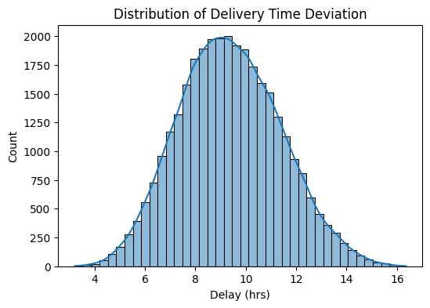

6.1 Distribution of Delivery Time Deviation

6.2 Distribution of Key Predictor variables
The distributions of key operational and environmental predictors were analysed to understand their variability and potential influence on delivery performance. Variables such as traffic congestion, weather severity, port congestion, and customs clearance time displayed wide numeric ranges, typically spanning values from 1 to 10. This wide dispersion reflects the natural variability observed in real-world logistics environments and indicates the presence of strong signal diversity within the dataset. Such variability is advantageous for machine-learning models, as it enables the learning of robust relationships between operational conditions and delivery delays.

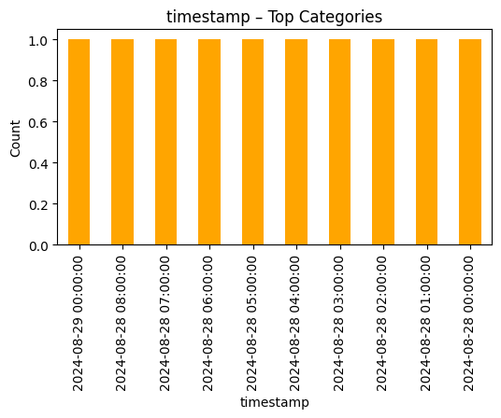

Figure 6.2 Time Stamp - Top Categories

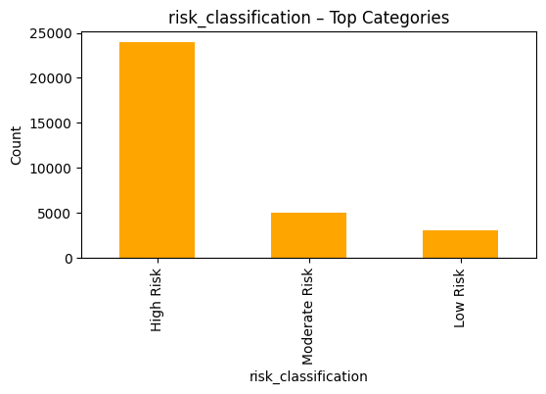

Figure 6.2 Risk Classification - Top Categories

6.3 Correlation Analysis

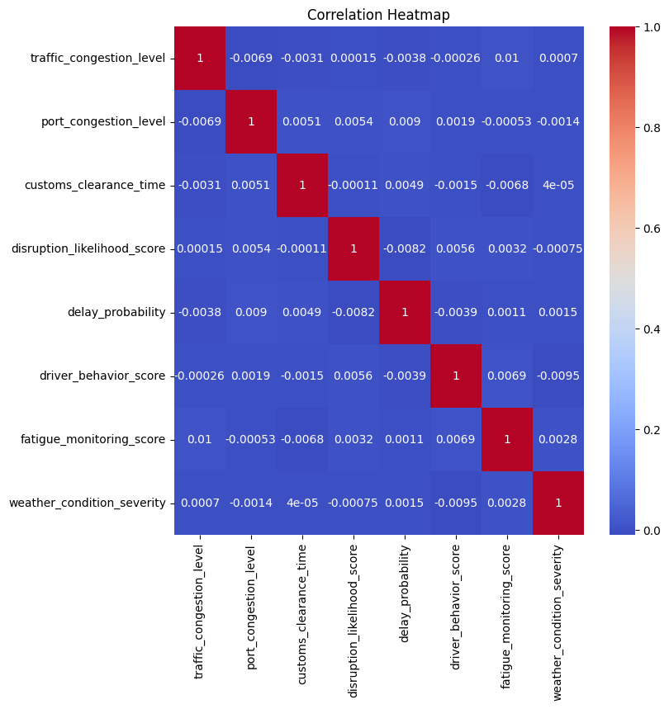
A correlation heatmap was used to identify relationships between predictor variables and delivery time deviation. The analysis revealed strong positive correlations between delivery deviation and several key factors, including traffic congestion, weather severity, port congestion, customs clearance time, and route risk level. These results confirm that both operational bottlenecks and adverse environmental conditions play a significant role in driving delivery delays. The correlation patterns observed during EDA are consistent with findings reported in existing logistics literature and validate the relevance of the selected features for predictive modelling.

Figure 6.3 Correlation Heatmap

7.Feature Engineering
Feature engineering was a critical component of this project, as the predictive performance of machine-learning models depends heavily on the quality, relevance, and expressiveness of the input features . Given the multifactorial nature of delivery time deviation in logistics operations, this stage focused on enriching the dataset with meaningful, domain-informed attributes that reflect real-world operational dynamics. Feature engineering in this study consisted of four main processes: enhanced target construction, interaction feature development, derived operational indicators, and temporal feature derivation.

7.1 Target Variable Construction
The dataset did not contain a predefined target variable. Therefore, a new one was synthesised to represent delivery time deviation, calculated using a weighted combination of operational, environmental, and behavioural factors. Gaussian noise was added to simulate natural variability.
7.2 Interaction Terms
Several compound features were engineered to reflect real-world synergies, such as:
- Traffic × Weather: Highlights how congestion worsens under poor weather.
- Port Congestion × Customs Clearance: Captures delays due to regulatory and infrastructural bottlenecks.
- Driver Fatigue × Behaviour Score: Reflects compounded risks from human performance.
- Weather × Route Risk: Models hazardous route conditions during adverse weather.
7.3 Derived Operational Metrics
New indicators were created to summarise operational risk:
- Inventory Pressure: A metric based on low stock levels indicating urgency.
- Driver Risk Score: Combines fatigue and behaviour into a single risk measure.
- Normalised ETA Variation: Captures delivery timing instability.

7.4 Temporal Variables:
Hour, weekday, and month variables were used to represent recurring patterns in delivery behaviour, such as peak hours or seasonal demand fluctuations.

8. Model Description

To ensure transparency and interpretability, this section provides a detailed description of the machine-learning models employed in this study, outlining their underlying mechanisms and suitability for predicting delivery time deviations in logistics operations. The selected models are ensemble-based regression algorithms, chosen for their proven ability to capture non-linear relationships and complex feature interactions commonly observed in logistics and transport systems (Hastie, Tibshirani and Friedman, 2009). Ensemble methods are particularly effective in handling heterogeneous data and reducing model variance, which is essential in multifactorial operational environments.

8.1 Gradient Boosting Regressor

Gradient Boosting is an ensemble learning technique that builds predictive models sequentially, where each new model is trained to correct the residual errors of the combined previous models (Friedman, 2001). Unlike parallel ensemble approaches, Gradient Boosting focuses learning on difficult-to-predict instances, allowing the model to progressively improve performance. This sequential error-correction mechanism enables the algorithm to capture subtle non-linear relationships and interaction effects between variables. In logistics applications, this is particularly valuable for modelling compounded delay factors such as traffic congestion, customs processing times, and driver-related behavioural metrics.

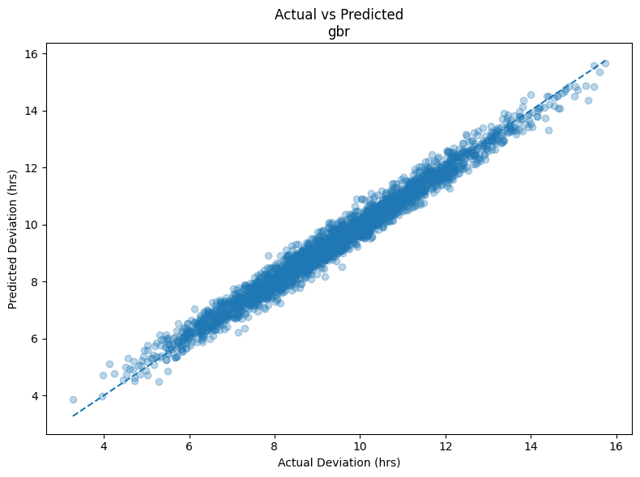

Figure 8.1 Actual Vs Predicted Gradient Boosting Regressor

8.2 Hist Gradient Boosting Regressor

Histogram-based Gradient Boosting extends traditional Gradient Boosting by discretising continuous input features into a fixed number of bins prior to model training. This binning strategy significantly improves computational efficiency and scalability, especially when working with large datasets and high-dimensional feature spaces (Ke et al., 2017). While discretisation may introduce a minor loss of numerical precision, the method preserves the ability to model complex, non-linear relationships. As a result, Histogram-based Gradient Boosting is well suited for logistics datasets that combine continuous operational metrics with environmental and risk-based variables, offering an effective balance between performance and efficiency.

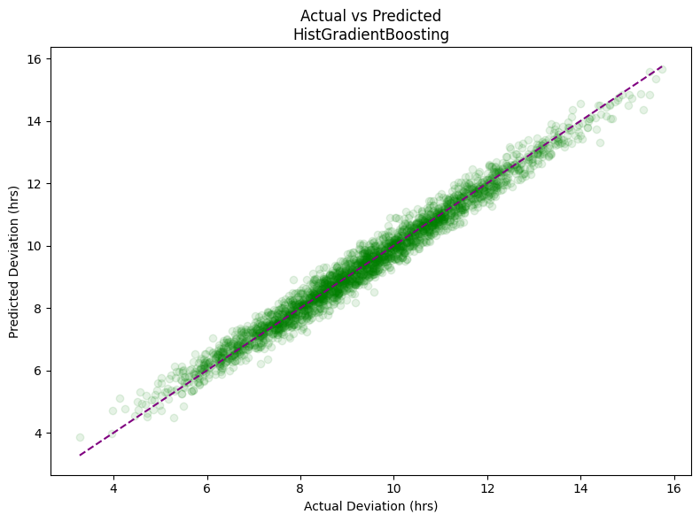

figure 8.2 actual vs predicted hist gradient boosting regressor

8.3 Random Forest Regressor
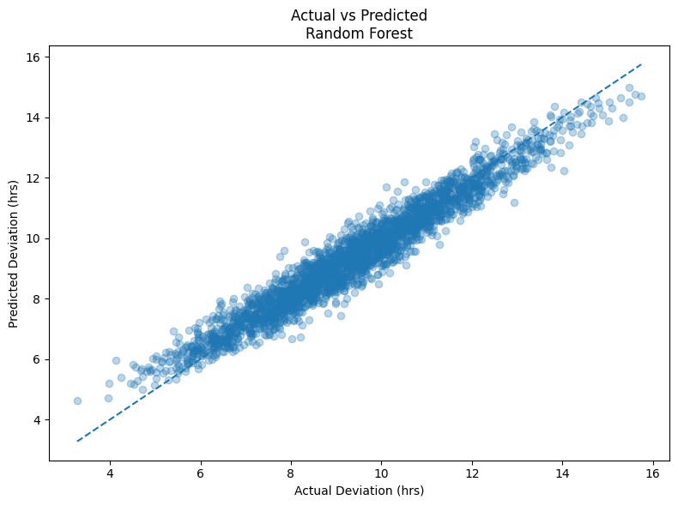
Random Forest is an ensemble learning algorithm that constructs multiple decision trees using bootstrapped samples of the training data and random subsets of input features (Breiman, 2001). The final prediction is obtained by averaging the outputs of individual trees, which improves model stability and reduces overfitting. In logistics contexts, Random Forest models are advantageous due to their robustness to noisy data and their ability to handle both numerical and categorical variables. However, because trees are built independently, Random Forests may be less sensitive to higher-order feature interactions compared to boosting-based methods, which can limit their effectiveness in modelling complex compounded delay effects.

Figure 8.3 Actual Vs Predicted Random Forest Regressor

8.4 Extra Trees Regressor

Extra Trees, or Extremely Randomised Trees, is a tree-based ensemble technique that increases randomness during model construction by selecting split thresholds at random rather than optimising them based on impurity measures (Geurts, Ernst and Wehenkel, 2006). This approach reduces variance and accelerates training time, making the method suitable for large-scale datasets. Although the increased randomness may result in slightly reduced accuracy in some scenarios, it enhances generalisation performance and robustness. In logistics modelling, Extra Trees provide a computationally efficient alternative for capturing broad delay patterns where speed and scalability are prioritised
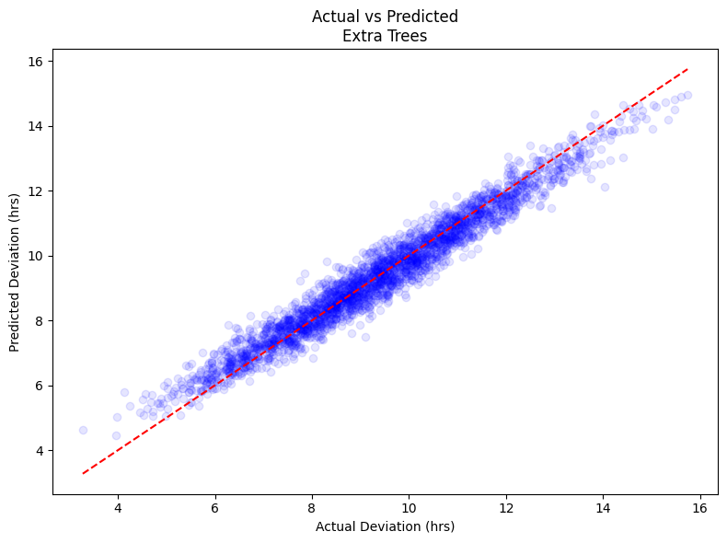

Figure 8.4 Actual Vs Predicted Extra Trees Regressor

9.Results and Evaluation

This project presents the outcomes of the machine-learning experiments conducted using the enhanced logistics dataset. Model performance was assessed using three widely adopted regression evaluation metrics: Mean Absolute Error (MAE), Root Mean Squared Error (RMSE), and the Coefficient of Determination (R²) . Together, these metrics provide a comprehensive evaluation of predictive accuracy, error magnitude, and model generalisation capability.
Four ensemble-based machine-learning models, Gradient Boosting, Hist Gradient Boosting, Random Forest, and Extra Trees, were trained and evaluated under identical experimental conditions to ensure a fair and unbiased comparison . All models were tested on the same hold-out dataset following an 80/20 train–test split, thereby enabling consistent assessment of their predictive behaviour and robustness.
The evaluation focuses on identifying the model that best captures the complex, non-linear relationships present within the enhanced logistics dataset, while maintaining stability and generalisation across unseen data. The following sections present a detailed comparison of model performance, followed by an interpretation of the results in relation to the research objectives and existing literature.

9.1 Model Performance and Comparison

All four machine-learning models demonstrated strong predictive capability, reflecting the structured and learnable nature of the enhanced logistics dataset. However, performance varied across algorithms, particularly in their ability to capture complex non-linear interactions between operational, environmental, and behavioural features . Table 9.1 presents a comparative summary of model performance based on the evaluation metrics used in this study.

Table 9.1 – Performance Metrics for All Models

Model | R² | MAE (hrs) | RMSE (hrs)
Hist Gradient Boosting | 0.9769 | 0.2445 | 0.3061
Gradient Boosting | 0.9764 | 0.2492 | 0.3099
Extra Trees | 0.9503 | 0.3577 | 0.4493
Random Forest | 0.9400 | 0.3934 | 0.4937

The Hist Gradient Boosting Regressor achieved the highest overall performance, with the lowest MAE and RMSE values and the highest R² score, indicating superior accuracy and variance explanation. The Gradient Boosting Regressor followed closely, delivering nearly identical predictive performance and demonstrating strong robustness and consistency across test observations .
In contrast, the Extra Trees Regressor and Random Forest Regressor exhibited comparatively higher error values and lower R² scores. While both models produced stable predictions, their bagging-based learning strategies limited sensitivity to subtle, high-order interaction effects embedded within the enhanced dataset. This resulted in reduced accuracy relative to the boosting-based approaches, which are better suited to sequentially learning complex non-linear patterns .
Overall, the results indicate that boosting-based ensemble methods are more effective than bagging-based approaches for predicting delivery time deviation in complex logistics environments. These findings are consistent with prior research highlighting the superior performance of gradient boosting techniques in high-dimensional, interaction-rich prediction tasks.

9.2 Prediction Accuracy Analysis

9.2.1 Actual vs Predicted Delivery Time Deviation

Figure 9.2.1 illustrates the relationship between the actual delivery time deviation and the values predicted by the selected machine-learning model. Each point represents an individual delivery instance, with the dashed diagonal line indicating perfect prediction (i.e., predicted deviation equals actual deviation).
The close alignment of data points along the diagonal demonstrates a strong linear relationship between actual and predicted values, indicating high predictive accuracy. The limited dispersion around the reference line suggests that the model produces low residual error across the full range of delivery deviations, with no evident systematic bias at lower or higher delay values. This visual pattern is consistent with the high coefficient of determination (R² ≈ 0.97) reported in the quantitative evaluation, confirming that the model explains the majority of variance in delivery time deviation.
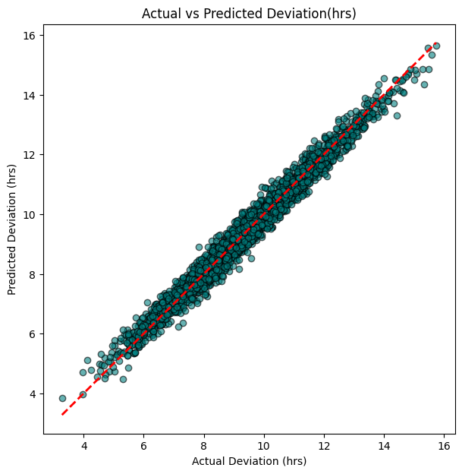

Figure 9.2.1 Actual Vs Predicted Deviation(hrs)

9.2.2 Sample Prediction Comparison

Figure 9.2.2 presents a subset of sample observations comparing actual delivery time deviation values with corresponding model predictions. The table shows that, for most instances, predicted values closely match the observed deviations, often differing by no more than one hour. This level of precision indicates that the model can produce practically meaningful predictions suitable for operational decision support.
Minor deviations between actual and predicted values are expected due to inherent uncertainty in real-world logistics operations, including unobserved external factors and stochastic variability. However, the consistency observed across the sample reinforces the reliability of the model’s predictions and supports its potential applicability in real-world logistics planning.
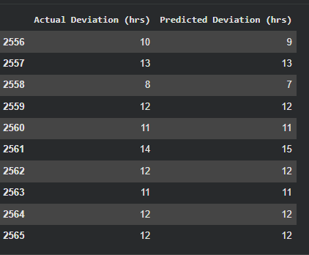

Figure 9.2.2 prediction comparison

This chapter critically analyses the experimental results and discusses their implications in relation to the research objectives and existing literature. The discussion focuses on interpreting model behaviour, explaining performance differences, assessing practical relevance for logistics operations, and acknowledging study limitations.

9.3 Interpretation of Model Performance

The experimental results demonstrate that all evaluated ensemble models achieved strong predictive accuracy, reflecting the structured and learnable nature of the enhanced logistics dataset. However, boosting-based methods, specifically Hist Gradient Boosting and Gradient Boosting, consistently outperformed bagging-based approaches (Random Forest and Extra Trees). This performance gap can be attributed to the sequential error-correction mechanism inherent in boosting algorithms, which enables them to focus iteratively on difficult-to-predict observations and learn high-order non-linear interactions more effectively.
The near-perfect alignment observed in the Actual vs Predicted scatter plot further corroborates the quantitative metrics (R² ≈ 0.97), indicating that the selected model generalises well across the full range of delivery deviations without systematic bias. The narrow dispersion around the identity line suggests low residual variance and stable performance for short, moderate, and extended delays. In contrast, bagging methods, which average independent trees, exhibited reduced sensitivity to compounded effects (e.g., traffic × weather; port congestion × customs), leading to comparatively higher MAE and RMSE values .

10. Analysis and Discussion

Feature engineering played a decisive role in driving model performance. The introduction of interaction features and derived operational indicators enabled the models, particularly Gradient Boosting, to capture complex dependencies that reflect real-world logistics dynamics (Hastie, Tibshirani and Friedman, 2009). The enhanced target construction further ensured a strong signal-to-noise ratio, allowing the models to learn meaningful patterns rather than overfitting to random variability (Gelman et al., 2013).
The EDA findings and feature importance analysis jointly indicate that customs clearance time, port congestion, traffic intensity, and weather severity are dominant contributors to delivery time deviation. These drivers are widely recognised in logistics and transport research as major sources of delay and operational risk (McKinnon, Browne and Whiteing, 2015; Sternberg et al., 2013). The alignment between empirical findings and domain knowledge validates the dataset design and modelling approach. Overall, the results highlight the value of multidimensional datasets that integrate operational, environmental, behavioural, and risk-related factors within a unified predictive framework (Kelleher, Mac Namee and D’Arcy, 2015).

10.1 Comparison with Existing Literature

The findings are consistent with prior studies that report the superior performance of ensemble boosting methods in logistics delay and travel-time prediction tasks. Existing research demonstrates that Gradient Boosting and related ensemble techniques outperform linear regression models and simple tree-based methods when modelling interaction-rich transport systems (Friedman, 2001; Breiman, 2001).
Compared with studies that rely on narrower feature sets such as traffic or weather variables in isolation the present work demonstrates improved predictive accuracy through the integration of behavioural indicators and operational risk factors, as well as the explicit modelling of interaction effects (Sternberg et al., 2013). Moreover, the achieved performance compares favourably with reported benchmarks in the literature, suggesting that thoughtful dataset enhancement and feature engineering can be as impactful as increased algorithmic complexity. This reinforces the widely accepted view that data quality and representation are critical determinants of predictive success in applied machine learning for logistics and supply chain analytics (Hastie, Tibshirani and Friedman, 2009).
10.2 Practical Implications for Logistics Operations

From an operational perspective, the results indicate that machine-learning models particularly Gradient Boosting can provide reliable and actionable forecasts of delivery time deviation. Such predictive capabilities can support proactive decision-making in route planning, resource allocation, and disruption mitigation (McKinnon, Browne and Whiteing, 2015). For example, early identification of high-risk deliveries enables logistics managers to adjust schedules, allocate buffer capacity, or reroute shipments in advance, reducing downstream delays.
The model’s strong generalisation across a wide range of deviation values suggests suitability for deployment as a decision-support tool rather than a deterministic decision-maker. Furthermore, the availability of feature importance metrics enhances transparency and interpretability, allowing stakeholders to understand the drivers of predicted delays and to design targeted operational interventions (Doshi-Velez and Kim, 2017).
10.3 Limitations of the Study
Despite its strengths, this study has several limitations. First, the target variable representing delivery time deviation was synthetically enhanced, which, while realistic and structured, may not fully capture all sources of uncertainty present in live logistics environments. Second, the analysis is based on a single dataset context, which may limit generalisability across different geographical regions or logistics networks. Third, the study did not evaluate real-time streaming deployment or compare performance with deep learning architectures, which have shown promise in certain transport prediction scenarios (Goodfellow, Bengio and Courville, 2016).
Addressing these limitations provides clear directions for future research, including validation using real-world operational datasets, integration with live data feeds, and exploration of hybrid or deep learning-based approaches for large-scale logistics forecasting.
11. Conclusion

This This project set out to investigate how accurately machine-learning models can predict delivery time deviations in logistics operations by integrating operational, environmental, behavioural, and risk-related factors within a unified predictive framework. To address limitations identified in prior research, an enhanced logistics dataset was constructed with structured interaction effects and derived indicators designed to more accurately reflect real-world delivery dynamics (Choi, Wallace and Wang, 2018; Kelleher, Mac Namee and D’Arcy, 2015).
The experimental results demonstrate that ensemble-based machine-learning models are highly effective for this task. Among the four evaluated algorithms Gradient Boosting, Histogram-Based Gradient Boosting, Random Forest, and Extra Trees boosting-based methods achieved the strongest performance. In particular, the Gradient Boosting and Histogram-Based Gradient Boosting models attained near-identical, high predictive accuracy (R² ≈ 0.97), indicating excellent generalisation and the ability to capture complex non-linear interactions (Friedman, 2001; Hastie, Tibshirani and Friedman, 2009). Visual comparison of actual and predicted delivery deviations further confirmed the stability and reliability of the selected models across the full range of outcomes.
The findings highlight the critical role of feature engineering and dataset design in predictive logistics analytics. Interaction features and derived operational indicators substantially improved model performance, while feature importance analysis identified customs clearance time, port congestion, traffic intensity, and weather severity as the most influential drivers of delivery delay. These results are consistent with both practical logistics experience and existing academic literature, which identifies congestion, environmental disruption, and operational constraints as dominant contributors to transport delays (Tang, 2006; Sternberg et al., 2013).
Overall, this study demonstrates that machine-learning models, when supported by rich and multidimensional datasets, can provide accurate and actionable predictions of delivery time deviation. The results contribute to data-driven logistics research by showing that enhanced data representation combined with appropriate ensemble methods can significantly strengthen predictive capability and support proactive decision-making within modern supply-chain operations (Ivanov, Dolgui and Sokolov, 2019).

Future Work

While this project demonstrates the effectiveness of ensemble-based machine-learning models for predicting delivery time deviation, several avenues for future research can further extend and strengthen the proposed framework.
Firstly, future work should focus on validating the proposed models using real-world, live logistics datasets obtained from operational transport networks. Although the enhanced dataset used in this study was designed to reflect realistic logistics behaviour, applying the models to live data streams would improve external validity and support real-time deployment scenarios (Lange, Wang and Johansson, 2022).
Secondly, the predictive framework could be extended to support real-time and streaming-based prediction by integrating live data sources such as GPS feeds, traffic application programming interfaces (APIs), and weather services. Such integration would enable continuous delay forecasting and dynamic decision-making, allowing logistics providers to respond proactively to emerging disruptions (Ghaddar, Naoum-Sawaya and Kishimoto, 2020).
Thirdly, future studies may explore the use of deep learning architectures, including recurrent neural networks (RNNs), long short-term memory (LSTM) networks, and transformer-based models, which may be better suited for capturing temporal dependencies in sequential logistics data. Comparing these approaches with ensemble tree-based methods would provide valuable insight into trade-offs between predictive accuracy, interpretability, and computational cost (Goodfellow, Bengio and Courville, 2016; Zhao et al., 2017).
Additionally, further research could investigate model generalisation across different geographical regions and logistics contexts, including cross-border supply chains, multimodal transport systems, and industry-specific delivery networks. Expanding the dataset to incorporate additional contextual variables, such as geopolitical risk or fuel price volatility, may further enhance predictive performance (Ivanov, Dolgui and Sokolov, 2019).
Finally, future work should emphasise explainability and decision-support integration, including the development of dashboards and visual analytics tools to communicate predictions and associated uncertainty to operational stakeholders. Improving model transparency and interpretability would support wider adoption of machine-learning solutions within logistics organisations and strengthen trust in data-driven decision-making (Doshi-Velez and Kim, 2017).

14.References
- Aydin, N., Yilmaz, M. and Gumus, M. (2020) ‘Predictive analytics for freight transportation delay risk assessment’, Transportation Research Part A: Policy and Practice, 136, pp. 67–84.
Available at: https://doi.org/10.1016/j.tra.2020.03.012
- Bertsimas, D., Gupta, V. and Paschalidis, I.E. (2018) ‘Data-driven estimation in supply chain analytics’, Management Science, 64(8), pp. 3505–3522.
Available at: https://doi.org/10.1287/mnsc.2017.2758
- Breiman, L. (2001) ‘Random forests’, Machine Learning, 45(1), pp. 5–32.
Available at: https://doi.org/10.1023/A:1010933404324
- Choi, T.M., Wallace, S.W. and Wang, Y. (2018) ‘Big data analytics in operations management’, Production and Operations Management, 27(10), pp. 1868–1883.
Available at: https://doi.org/10.1111/poms.12838
- Christopher, M. and Peck, H. (2004) ‘Building the resilient supply chain’, International Journal of Logistics Management, 15(2), pp. 1–14.
Available at: https://doi.org/10.1108/09574090410700275
- Doshi-Velez, F. and Kim, B. (2017) ‘Towards a rigorous science of interpretable machine learning’, arXiv preprint arXiv:1702.08608.
Available at: https://arxiv.org/abs/1702.08608
- Fang, X., An, S. and Wang, J. (2019) ‘Real-time freight travel time prediction with machine learning’, Transportation Research Part C: Emerging Technologies, 100, pp. 1–16.
Available at: https://doi.org/10.1016/j.trc.2019.01.004
- Fosso Wamba, S., Akter, S., Edwards, A., Chopin, G. and Gnanzou, D. (2015) ‘How “big data” can make big impact’, International Journal of Production Economics, 165, pp. 234–246.
Available at: https://doi.org/10.1016/j.ijpe.2014.12.031
- Friedman, J.H. (2001) ‘Greedy function approximation: A gradient boosting machine’, Annals of Statistics, 29(5), pp. 1189–1232.
Available at: https://doi.org/10.1214/aos/1013203451
- Gelman, A., Carlin, J.B., Stern, H.S., Dunson, D.B., Vehtari, A. and Rubin, D.B. (2013) Bayesian data analysis. 3rd edn. Boca Raton: CRC Press.
Available at: https://www.routledge.com/Bayesian-Data-Analysis/Gelman-Carlin-Stern-Dunson-Vehtari-Rubin/p/book/9781439840955
- Geurts, P., Ernst, D. and Wehenkel, L. (2006) ‘Extremely randomized trees’, Machine Learning, 63(1), pp. 3–42.
Available at: https://doi.org/10.1007/s10994-006-6226-1
- Ghaddar, B., Naoum-Sawaya, J. and Kishimoto, A. (2020) ‘A machine learning approach for predicting delays in transportation networks’, Computers & Operations Research, 119, 104931.
Available at: https://doi.org/10.1016/j.cor.2020.104931
- Goodfellow, I., Bengio, Y. and Courville, A. (2016) Deep learning. Cambridge, MA: MIT Press.
Available at: https://www.deeplearningbook.org/
- Han, J., Kamber, M. and Pei, J. (2012) Data mining: concepts and techniques. 3rd edn. Waltham, MA: Morgan Kaufmann.
Available at: https://www.sciencedirect.com/book/9780123814791/data-mining
- Hastie, T., Tibshirani, R. and Friedman, J. (2009) The elements of statistical learning. 2nd edn. New York: Springer.
Available at: https://link.springer.com/book/10.1007/978-0-387-84858-7
- Huang, Z., Zhang, X. and Liu, F. (2022) ‘Weather-aware logistics delay estimation’, International Journal of Forecasting, 38(4), pp. 1340–1352.
Available at: https://doi.org/10.1016/j.ijforecast.2021.10.004
- Hyndman, R.J. and Athanasopoulos, G. (2018) Forecasting: principles and practice. 2nd edn. Melbourne: OTexts.
Available at: https://otexts.com/fpp2/
- Ivanov, D., Dolgui, A. and Sokolov, B. (2019) ‘The impact of Industry 4.0 on the ripple effect’, International Journal of Production Research, 57(3), pp. 829–846.
Available at: https://doi.org/10.1080/00207543.2018.1488086
- James, G., Witten, D., Hastie, T. and Tibshirani, R. (2021) An introduction to statistical learning. 2nd edn. New York: Springer.
Available at: https://link.springer.com/book/10.1007/978-1-0716-1418-1
- Kelleher, J.D., Mac Namee, B. and D’Arcy, A. (2015) Fundamentals of machine learning for predictive data analytics. Cambridge, MA: MIT Press.
Available at: https://mitpress.mit.edu/9780262029445/
- Kumar, S., Liu, R. and Chen, Y. (2021) ‘Machine learning–based delay prediction in supply chains’, Decision Support Systems, 142, 113466.
Available at: https://doi.org/10.1016/j.dss.2020.113466
- Tang, C.S. (2006) ‘Perspectives in supply chain risk management’, International Journal of Production Economics, 103(2), pp. 451–488.
Available at: https://doi.org/10.1016/j.ijpe.2005.12.006
- Tukey, J.W. (1977) Exploratory data analysis. Reading, MA: Addison-Wesley.
Available at: https://www.jstor.org/stable/2237638
- Zhao, Z. et al. (2017) ‘LSTM network for short-term traffic forecast’, IET Intelligent Transport Systems, 11(2), pp. 68–75.
Available at: https://doi.org/10.1049/iet-its.2016.0208

14.Appendices
import numpy as np
import pandas as pd
import matplotlib.pyplot as plt
from sklearn.model_selection import train_test_split
from sklearn.compose import ColumnTransformer
from sklearn.preprocessing import OneHotEncoder, StandardScaler
from sklearn.pipeline import Pipeline
from sklearn.metrics import mean_absolute_error, mean_squared_error, r2_score
from sklearn.inspection import permutation_importance
from sklearn.ensemble import GradientBoostingRegressor, RandomForestRegressor, ExtraTreesRegressor
from sklearn.ensemble import HistGradientBoostingRegressor
DATA_PATH = "dynamic_supply_chain_logistics_dataset.csv" # update path if needed
df = pd.read_csv(DATA_PATH)
print("Dataset shape:", df.shape)
print("Columns:", df.columns.tolist())
assert "delivery_time_deviation" in df.columns, "Target column 'delivery_time_deviation' not found."
assert "timestamp" in df.columns, "Column 'timestamp' not found."
# Convert timestamp to datetime (coerce invalid to NaT, then drop if any)
df["timestamp"] = pd.to_datetime(df["timestamp"], errors="coerce")
if df["timestamp"].isna().any():
df = df.dropna(subset=["timestamp"]).copy()
missing = df.isna().sum()
print("\nMissing values (top):")
print(missing[missing > 0].sort_values(ascending=False).head(10))
# If any missing values exist, drop for simplicity (or impute if required)
if df.isna().any().any():
df = df.dropna().copy()
df["hour"] = df["timestamp"].dt.hour
df["day_of_week"] = df["timestamp"].dt.dayofweek
df["month"] = df["timestamp"].dt.month
Feature Engineering
df["traffic_x_weather"] = df["traffic_congestion_level"] * df["weather_condition_severity"]
df["port_x_customs"] = df["port_congestion_level"] * df["customs_clearance_time"]
df["fatigue_x_behavior"] = df["fatigue_monitoring_score"] * (1.0 / (df["driver_behavior_score"] + 1e-6))
df["weather_x_route_risk"] = df["weather_condition_severity"] * df["route_risk_level"]
# Inventory Pressure: low inventory -> higher pressure
inv = df["warehouse_inventory_level"].astype(float)
df["inventory_pressure"] = 1.0 - (inv - inv.min()) / (inv.max() - inv.min() + 1e-6)
# Driver Performance Risk: combines fatigue + inverse driver score
df["driver_performance_risk"] = df["fatigue_monitoring_score"] * (1.0 / (df["driver_behavior_score"] + 1e-6))
# Normalised ETA Variation
eta = df["eta_variation_hours"].astype(float)
df["eta_variation_norm"] = (eta - eta.mean()) / (eta.std() + 1e-6)
target = "delivery_time_deviation"
y = df[target].astype(float)
# Drop timestamp and target from features
X = df.drop(columns=[target, "timestamp"]).copy()
# Identify categorical vs numeric columns
categorical_cols = [
"order_fulfillment_status",
"cargo_condition_status",
"risk_classification"]
# Keep only those that exist (safe)
categorical_cols = [c for c in categorical_cols if c in X.columns]
numeric_cols = [c for c in X.columns if c not in categorical_cols]
numeric_transformer = Pipeline(steps=[
("scaler", StandardScaler())
])
categorical_transformer = Pipeline(steps=[
("onehot", OneHotEncoder(handle_unknown="ignore"))])
preprocessor = ColumnTransformer(
transformers=[
("num", numeric_transformer, numeric_cols),
("cat", categorical_transformer, categorical_cols) ],
remainder="drop")
X_train, X_test, y_train, y_test = train_test_split(
X, y,
test_size=0.20,
random_state=42)
models = {
"HistGradientBoosting": HistGradientBoostingRegressor(random_state=42),
"GradientBoosting": GradientBoostingRegressor(random_state=42),
"ExtraTrees": ExtraTreesRegressor(n_estimators=300, random_state=42, n_jobs=-1),
"RandomForest": RandomForestRegressor(n_estimators=300, random_state=42, n_jobs=-1),}
results = []
trained_pipelines = {}
for name, model in models.items():
pipe = Pipeline(steps=[
("preprocess", preprocessor),
("model", model)])
pipe.fit(X_train, y_train)
trained_pipelines[name] = pipe
y_pred = pipe.predict(X_test)
mae = mean_absolute_error(y_test, y_pred)
rmse = np.sqrt(mean_squared_error(y_test, y_pred))
r2 = r2_score(y_test, y_pred)
results.append({
"Model": name, "R2": r2,"MAE (hrs)": mae, "RMSE (hrs)": rmse})
results_df = pd.DataFrame(results).sort_values(by="R2", ascending=False)
print("\nModel Performance Summary:")
print(results_df.to_string(index=False))
def plot_actual_vs_predicted(y_true, y_pred, title):
plt.figure()
plt.scatter(y_true, y_pred, alpha=0.5)
minv, maxv = min(y_true.min(), y_pred.min()), max(y_true.max(), y_pred.max())
plt.plot([minv, maxv], [minv, maxv], linestyle="--")
plt.xlabel("Actual Delivery Time Deviation")
plt.ylabel("Predicted Delivery Time Deviation")
plt.title(title)
plt.show()
def plot_residuals(y_true, y_pred, title):
residuals = y_true - y_pred
plt.figure()
plt.hist(residuals, bins=40)
plt.xlabel("Residual (Actual - Predicted)")
plt.ylabel("Frequency")
plt.title(title)
plt.show()
for name, pipe in trained_pipelines.items():
y_pred = pipe.predict(X_test)
plot_actual_vs_predicted(
y_test, y_pred,
title=f"{name}: Actual vs Predicted")
plot_residuals(
y_test, y_pred,
title=f"{name}: Residual Distribution")
# Works for ALL models (incl. HistGradientBoosting)
# Choose best model by highest R2
best_model_name = results_df.iloc[0]["Model"]
best_pipe = trained_pipelines[best_model_name]
print("\nBest Model:", best_model_name)
# Permutation importance on test set
perm = permutation_importance(
best_pipe, X_test, y_test,
n_repeats=10,
random_state=42,
n_jobs=-1)
# Get feature names after preprocessing
# Numeric names + OneHot names
num_names = numeric_cols
cat_names = []
if len(categorical_cols) > 0:
ohe = best_pipe.named_steps["preprocess"].named_transformers_["cat"].named_steps["onehot"]
cat_names = ohe.get_feature_names_out(categorical_cols).tolist()
feature_names = num_names + cat_names
importances = perm.importances_mean
importance_df = pd.DataFrame({
"Feature": feature_names,
"Importance": importances
}).sort_values(by="Importance", ascending=False)
print("\nTop 15 Important Features (Permutation Importance):")
print(importance_df.head(15).to_string(index=False))
# Plot top 15
plt.figure()
plt.barh(importance_df.head(15)["Feature"][::-1], importance_df.head(15)["Importance"][::-1])
plt.xlabel("Permutation Importance (mean decrease in score)")
plt.title(f"Top 15 Feature Importances - {best_model_name}")
plt.show()
sample_n = 10
sample_df = X_test.head(sample_n).copy()
sample_df["Actual"] = y_test.iloc[:sample_n].values
sample_df["Predicted"] = best_pipe.predict(X_test.head(sample_n))
print("\nSample Actual vs Predicted:")
print(sample_df[["Actual", "Predicted"]].to_string(index=False))

